 Shri Ramdeobaba College of Engineering & Management, Nagpur 13

Department of Electronics Engineering

Instrumentation and control lab (ENP354)

Semester: V Session: 2023-24 Section: A Batch: A2

*************************************************************************************

Name of Student: Harsh Devendra Mishra Roll Number: A-22

Date of performance of Experiment: 31/09/2023 Date of Submission of Experiment file: 14/09/2023

*************************************************************************************

EXPERIMENT NO. 1

Aim of Experiment: - To perform the statistical analysis of the data set to determine Mean, Deviation from mean, Standard deviation and Variance. Also plot the normal distribution of the errors.

Objective of Experiment: - To analyze the change in variance by changing the no. of data set

Tool used: - Excel/Spreadsheet/Calculator

************************************************************************************************

Reading: - (Readings/Calculations): -

We are taking last 25 days Wind Speed as data and that are divided in three set as follows:

|  |  |  |  |
| --- | --- | --- | --- |
| SR NO | Set 1  (8 readings) | Set 2  (15 readings) | Set 3  (25 readings) |
| 1 | 60 | 56 | 50 |
| 2 | 51 | 60 | 53 |
| 3 | 49 | 55 | 56 |
| 4 | 44 | 80 | 58 |
| 5 | 43 | 67 | 60 |
| 6 | 66 | 59 | 48 |
| 7 | 56 | 83 | 45 |
| 8 | 58 | 56 | 51 |
| 9 |  | 89 | 55 |
| 10 |  | 65 | 62 |
| 11 |  | 76 | 67 |
| 12 |  | 66 | 65 |
| 13 |  | 49 | 66 |
| 14 |  | 61 | 80 |
| 15 |  | 91 | 83 |
| 16 |  |  | 87 |
| 17 |  |  | 91 |
| 18 |  |  | 48 |
| 19 |  |  | 51 |
| 20 |  |  | 59 |
| 21 |  |  | 65 |
| 22 |  |  | 69 |
| 23 |  |  | 76 |
| 24 |  |  | 78 |
| 25 |  |  | 81 |

Calculation: - For Set 1 -

# 1. Arithmetic Mean: -

# X = x1+x2+x3--------xn

N

|  |  |  |
| --- | --- | --- |
| SR NO | Set 1  (8 readings) | Arithmetic mean |
| 1 | 60 | 53.375 |
| 2 | 51 |
| 3 | 49 |
| 4 | 44 |
| 5 | 43 |
| 6 | 66 |
| 7 | 56 |
| 8 | 58 |

X = 60+51+49+44+43+66+56+58

8

X = Arithmetic Mean = 53.375

## 2. Deviation from Mean: -

# Formula = Dn = Xn - X

|  |  |  |
| --- | --- | --- |
| SR  NO | Set 1  (8 readings) | Deviation from mean |
| 1 | 60 | D1 = x1-x = 60 - 53.375 = 6.625 |
| 2 | 51 | D2 = x2-x = 51 - 53.375 = -2.375 |
| 3 | 49 | D3 = x3-x = 49 - 53.375 = -4.375 |
| 4 | 44 | D4 = x4-x = 44 - 53.375 = -9.375 |
| 5 | 43 | D5= x5-x = 43 - 53.375 = -10.375 |
| 6 | 66 | D6 = x6-x = 66 - 53.375 = 12.625 |
| 7 | 56 | D7 = x7-x = 56 - 53.375 = 2.625 |
| 8 | 58 | D8 = x8-x = 58 - 53.375 = 4.625 |

## 3. Average Deviation: -

Formula = D = |d1|+|d2|+|d3|---------|dn|

N

D = 6.625+2.375+4.375+9.375+10.375+12.625+2.625+4.625

8

Average Deviation = D = 6.626

## 4. Standard Deviation(σ): -

a.

Sample –

Formula

=

d

1

2

d

+

2

2

+

d

3

2

d

----------

n

2

n-1

=

6.62

2

+2.375

2

+4.375

2

+4.375

2

+9.375

2

+2.625

2

+4.625

2

+12.625

2

8-1

=

7.2042

b. Population –

Formula = d12+d22+d32---------dn2

n

= 6.625+2.375+4.375+9.375+10.375+12.625+2.625+4.625

8

= 6.738

## 5. Variance (σ^2): -

Formula = σ2 = (6.738)2 = 45.4006

For Set 2 –

1. Arithmetic mean –

|  |  |  |
| --- | --- | --- |
| Sr No | Set 2  (15 readings) | Arithmetic Mean |
| 1 | 56 | 67.54 |
| 2 | 60 |
| 3 | 55 |
| 4 | 80 |
| 5 | 67 |
| 6 | 59 |
| 7 | 83 |
| 8 | 56 |
| 9 | 89 |
| 10 | 65 |
| 11 | 76 |
| 12 | 66 |
| 13 | 49 |
| 14 | 61 |
| 15 | 91 |

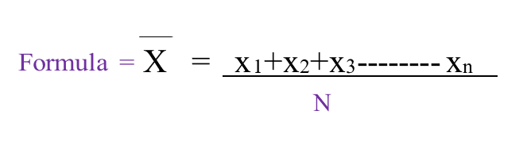

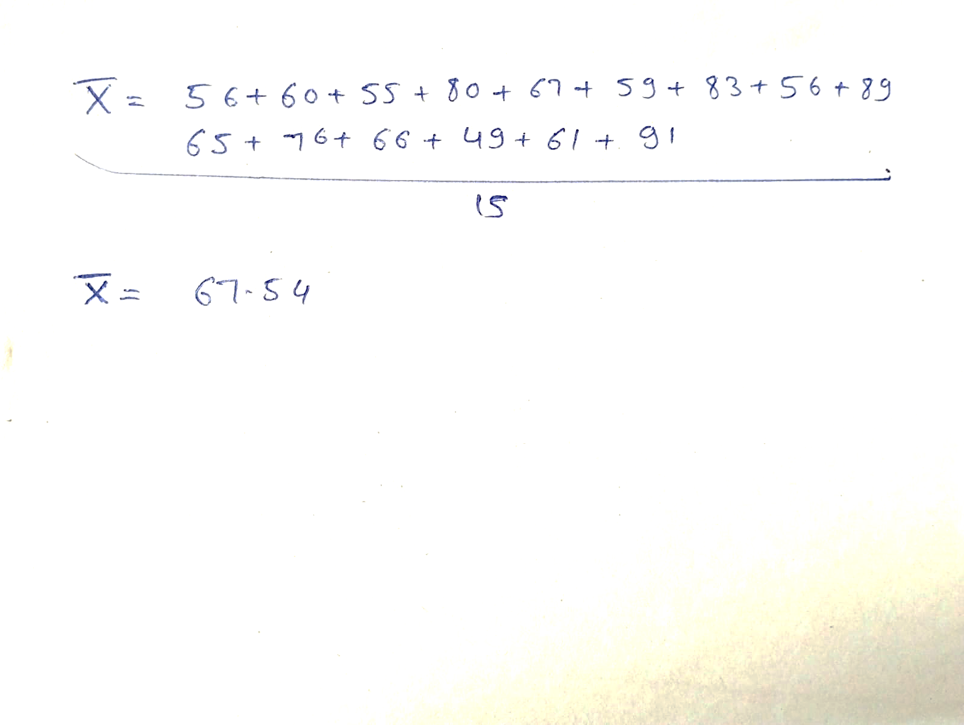

## 2. Deviation from Mean: -

|  |  |  |
| --- | --- | --- |
| SR NO | Set 2 readings | Deviation from mean |
| 1 | 56 | D1 = x1-x = 56 - 67.54 = -11.54 |
| 2 | 60 | D2 = x2-x = 60 - 67.54 = -7.54 |
| 3 | 55 | D3 = x3-x = 55 - 67.54 = -12.54 |
| 4 | 80 | D4 = x4-x = 80 - 67.54 = 12.46 |
| 5 | 67 | D5 = x5-x = 67 - 67.54 = -0.54 |
| 6 | 59 | D6 = x6-x = 59 - 67.54 = -8.54 |
| 7 | 83 | D7 = x7-x = 83 - 67.54 = 15.46 |
| 8 | 56 | D8 = x8-x = 56 - 67.54 = -11.54 |
| 9 | 89 | D9 = x9-x = 89 - 67.54 = 21.46 |
| 10 | 65 | D10 = x10-x = 65 - 67.54 = -2.54 |
| 11 | 76 | D11 = x11-x = 76 - 67.54 = 8.46 |
| 12 | 66 | D12 = x12-x = 66 - 67.54 = -1.54 |
| 13 | 49 | D13 = x13-x = 49 - 67.54 = -18.54 |
| 14 | 61 | D14 = x14-x = 61 - 67.54 = -6.54 |
| 15 | 91 | D15 = x15-x = 91 - 67.54 = 23.46 |

### 3. Average Deviation –

Formula = D = |d1|+|d2|+|d3|---------|dn|

n

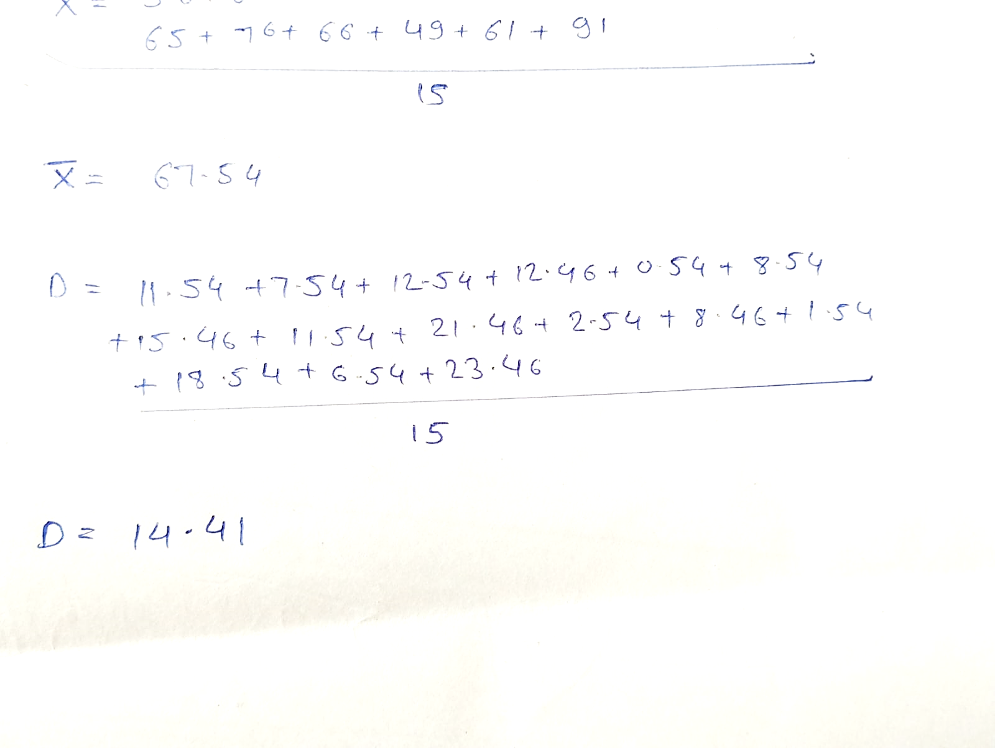

### 4. Standard Deviation(σ): -

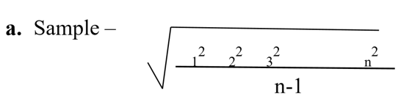

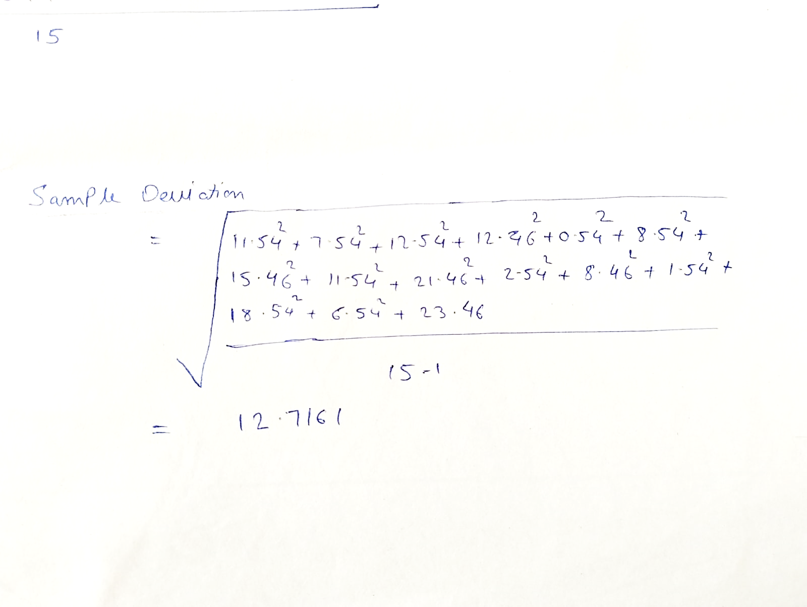

Formula = d + d + d + ---------- + dn

5 Variance (σ^2): -

Formula = σ2  = (12.7161)2 = 161.70

### For Set 3 readings –

|  |  |  |
| --- | --- | --- |
| SR NO | Set 3  (25 readings) | Arithmetic Mean |
| 1 | 50 | 64.16 |
| 2 | 53 |
| 3 | 56 |
| 4 | 58 |
| 5 | 60 |
| 6 | 48 |
| 7 | 45 |
| 8 | 51 |
| 9 | 55 |
| 10 | 62 |
| 11 | 67 |
| 12 | 65 |
| 13 | 66 |
| 14 | 80 |
| 15 | 83 |
| 16 | 87 |
| 17 | 91 |
| 18 | 48 |
| 19 | 51 |
| 20 | 59 |
| 21 | 65 |
| 22 | 69 |
| 23 | 76 |
| 24 | 78 |
| 25 | 81 |

# Formula = X = x1+x2+x3--------xn

n

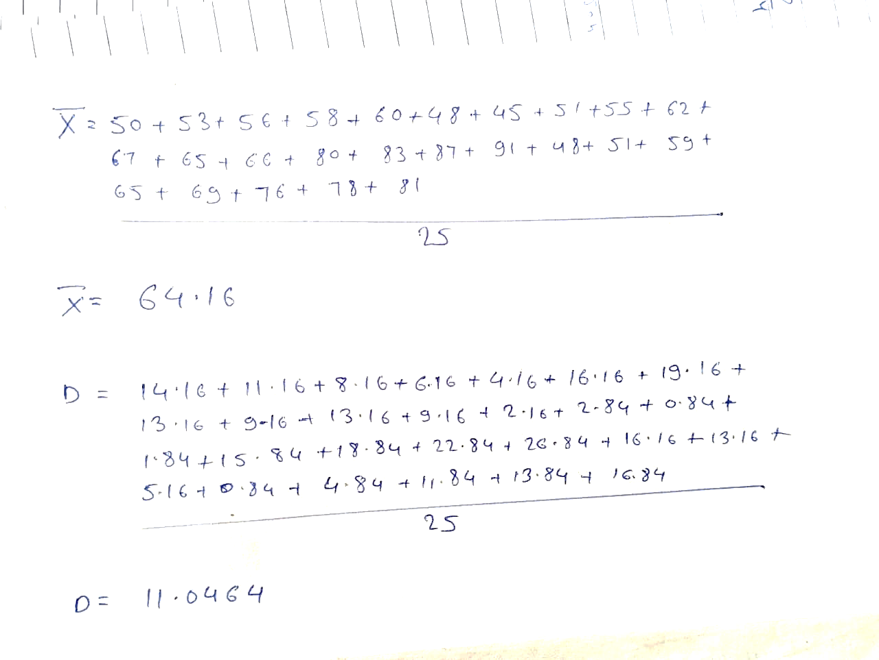

## 2. Deviation from Mean: -

|  |  |  |
| --- | --- | --- |
| SR NO | Set 3  (25 readings) | Deviation from Mean |
| 1 | 50 | D1 = x1 - x = 50 - 64.16 = - 14.16 |
| 2 | 53 | D2 = x2 - x = 53- 64.16 = - 11.16 |
| 3 | 56 | D3 = x3 - x = 56 - 64.16 = - 8.16 |
| 4 | 58 | D4 = x4 - x = 58- 64.16 = - 6.16 |
| 5 | 60 | D5 = x5 - x = 60- 64.16 = - 4.16 |
| 6 | 48 | D6 = x6 - x = 48- 64.16 = - 16.16 |
| 7 | 45 | D7 = x7 - x = 45- 64.16 = - 19.16 |
| 8 | 51 | D8 = x8 - x =51- 64.16 = 13.16 |
| 9 | 55 | D9 = x9 - x =55- 64.16 = -9.16 |
| 10 | 62 | D10 = x10 - x =62- 64.16 = - 2.16 |
| 11 | 67 | D11 = x11 - x =67- 64.16 = 2.84 |
| 12 | 65 | D12 = x12 - x =65- 64.16 = 0.84 |
| 13 | 66 | D13 = x13 - x =66- 64.16 = 1.84 |
| 14 | 80 | D14 = x14 - x =80 - 64.16 = 15.84 |
| 15 | 83 | D15 = x15 - x = 83 - 64.16 = 18.84 |
| 16 | 87 | D16 = x16 - x = 87 - 64.16 = 22.84 |
| 17 | 91 | D17 = x17 - x = 91 - 64.16 = 26.84 |
| 18 | 48 | D18 = x18 - x = 48 - 64.16 = - 16.16 |
| 19 | 51 | D19 = x19 - x = 51 - 64.16 = - 13.16 |
| 20 | 59 | D20 = x20 - x = 59 - 64.16 = - 5.16 |
| 21 | 65 | D21 = x21 - x = 65 - 64.16 = 0.84 |
| 22 | 69 | D22 = x22 - x = 69 - 64.16 = 4.84 |
| 23 | 76 | D23 = x23 - x = 76 - 64.16 = 11.84 |
| 24 | 78 | D24 = x24 - x = 78 - 64.16 = 13.84 |
| 25 | 81 | D25 = x25 - x = 81 - 64.16 = 16.84 |

### 3. Average Deviation –

Formula = D = |d1|+|d2|+|d3|---------|dn|

n



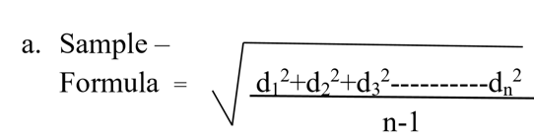

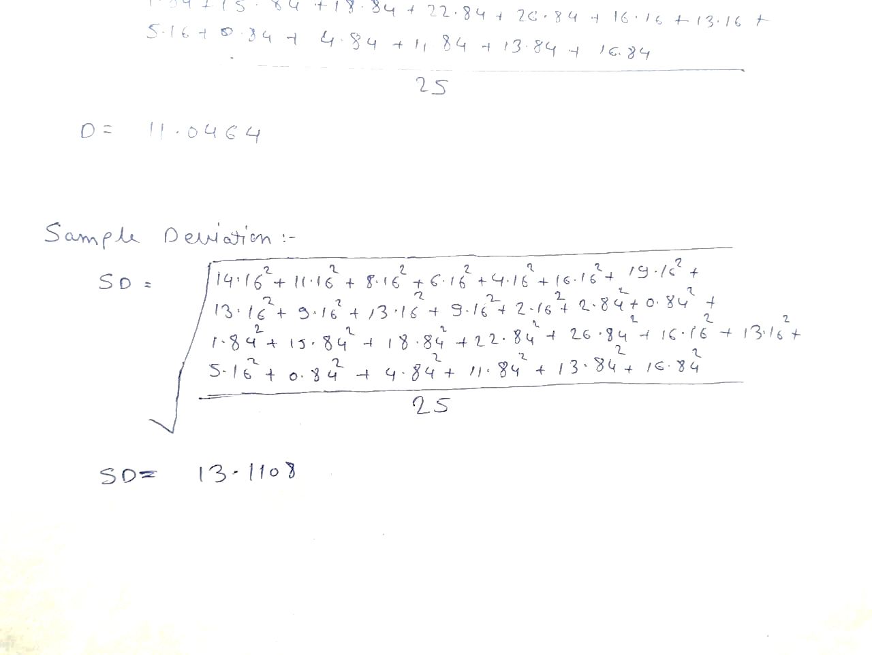

### 5. Variance (σ^2): -

Formula = σ2  = (13.1108)2 = 171.87

 Shri Ramdeobaba College of Engineering & Management, Nagpur 13

Department of Electronics Engineering

Instrumentation and control lab (ENP354)

Semester: V Session: 2023-24 Section: A Batch:A2

*************************************************************************************

Name of Student: Harsh Devendra Mishra Roll Number: A-22

Date of performance of Experiment: 14/09/2023 Date of Submission of Experiment file:21/09/2023

*************************************************************************************

EXPERIMENT NO. 2

Aim of Experiment: - Measurement of temperature using LM35 temperature sensor with Arduino

Objective of Experiment: - Measuring temperature using Analog or Digital sensor

Tool used: - Arduino, Temperature sensor, Breadboard, Connecting wires, Laptop/Computer system

***************************************************************************************************

The LM35 is an inexpensive, precision Centigrade temperature sensor made by Texas Instruments. It provides an output voltage that is linearly proportional to the Centigrade temperature and is, therefore, very easy to use with the Arduino.

The sensor does not require any external calibration or trimming to provide accuracies of ±0.5°C at room temperature and ±1°C over the −50°C to +155°C temperature range

LM35 pinout

The LM35 comes in 4 different packages, but the most common type is the 3-pin TO-92 transistor package.

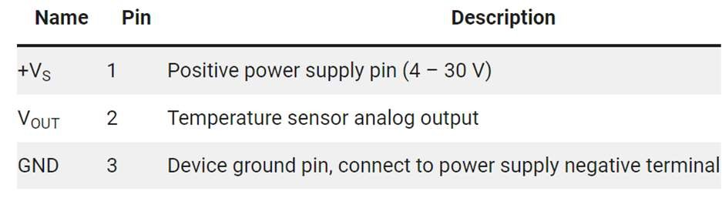

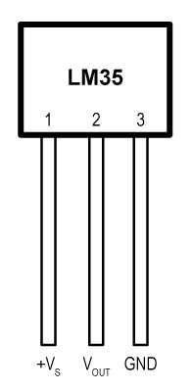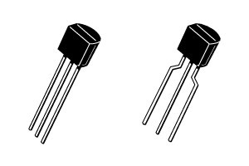

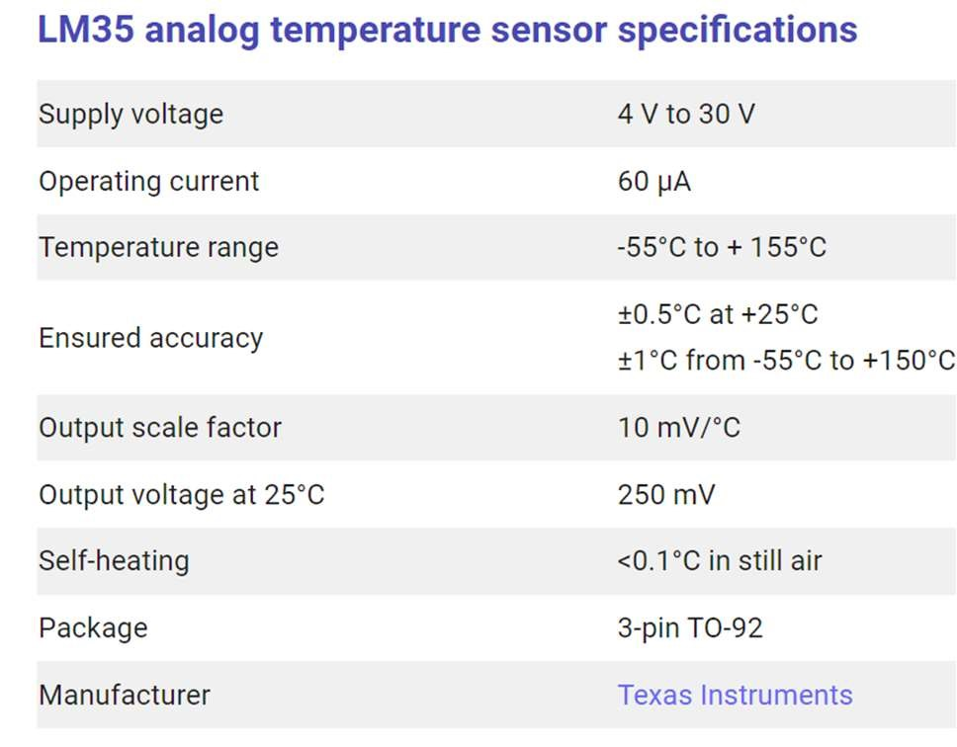Note that pin 1 (+VS) is the leftmost pin when the flat side of the sensor (with the text printed on it) is facing towards you.

Wiring – Connecting LM35 analog temperature sensor to Arduino

Connecting an LM35 to the Arduino is very easy as you only need to connect 3 pins. Start by connecting the +VS pin to the 5 V output of the Arduino and the GND pin to the ground.

Next, connect the middle pin (VOUT) to any of the analog inputs of the Arduino (for ex. A0)

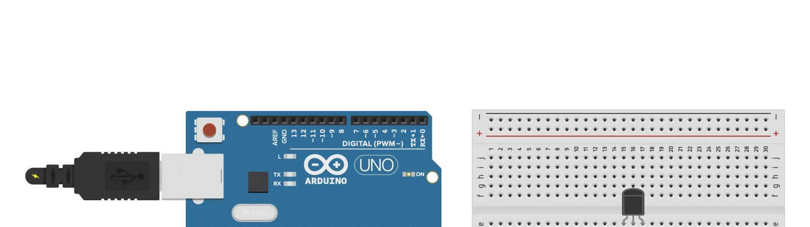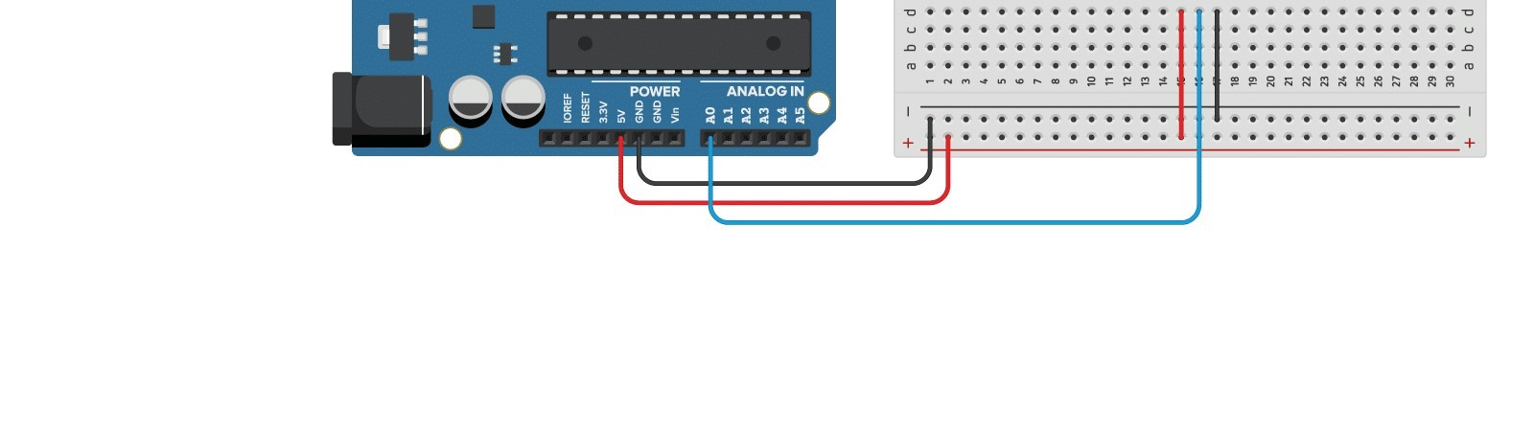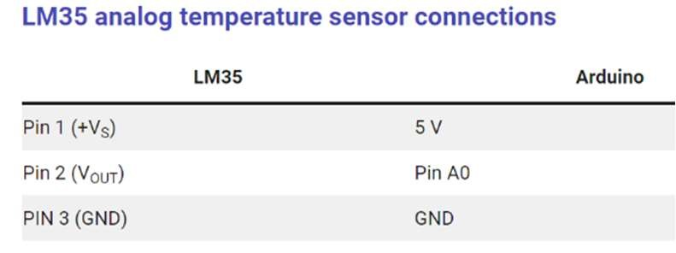

Write the code to read the temperature from an LM35 sensor and display it in the Serial Monitor.

Arduino Code:

void setup() {

Serial.begin(9600);

}

void loop() {

int sensorValue = analogRead(A0); float temp_val=sensorValue*0.48; float tempcel=(temp_val-0.5);

Serial.print("Sensor Value:");

Serial.println(sensorValue);

Serial.print("Temperature in Celsius:"); Serial.println(tempcel);

float tempfeh =(tempcel*9.0/5.0)+32.0;

Serial.print("Temperature in Fehrenhite:");

Serial.println(tempfeh);

Serial.println("");

delay(1000);

}

Result: - 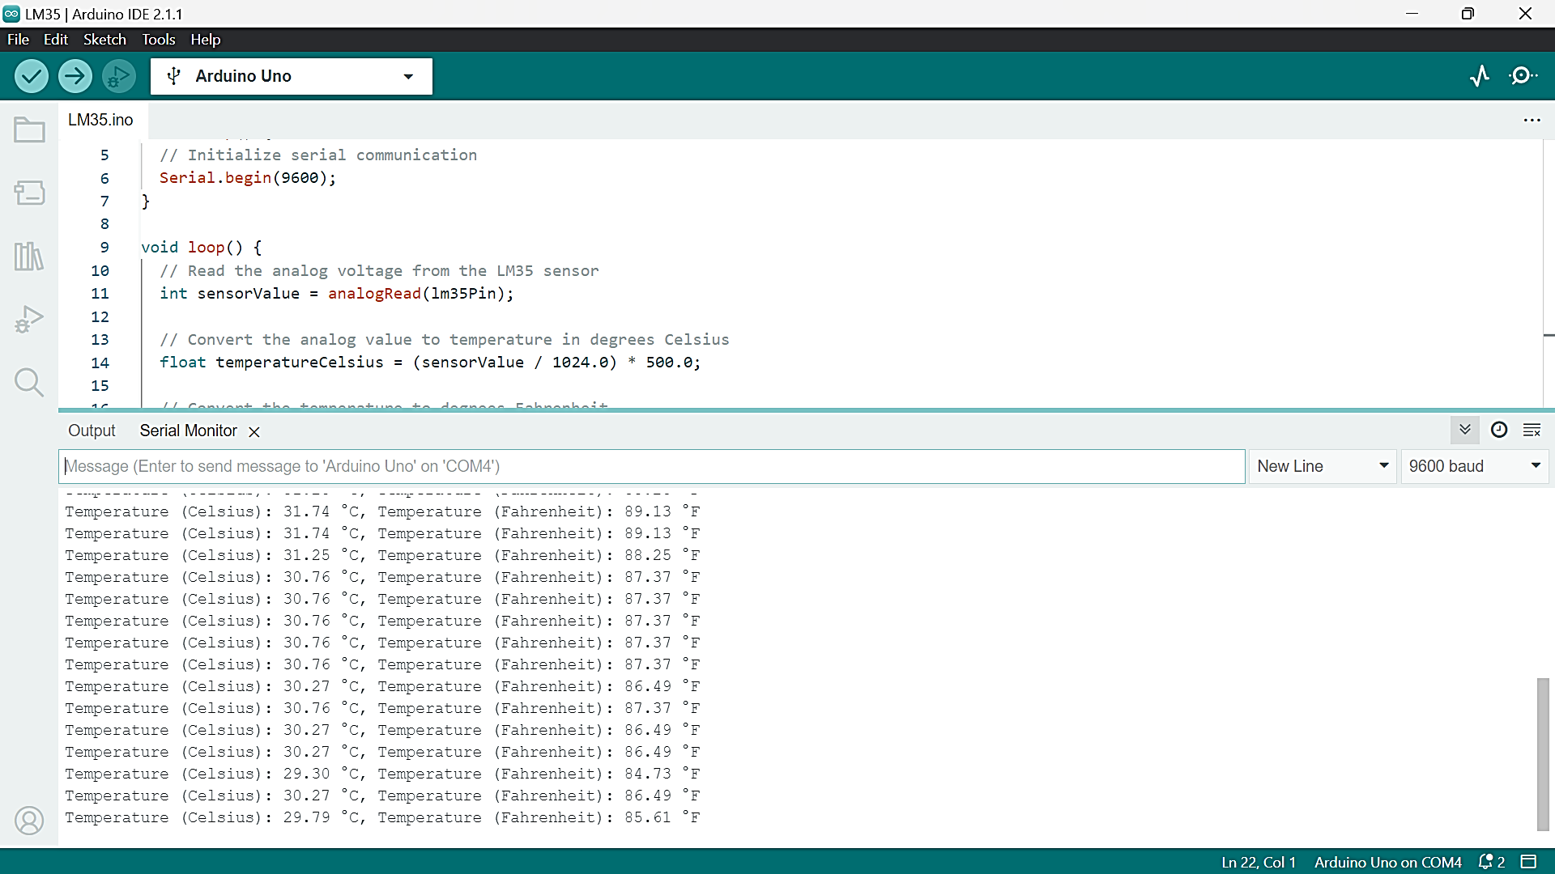

### Graph: -

|  |  |  |  |  |  |  |  |  |  |  |  |  |  |  |  |  |  |  |  |  |  |  |  |  |  |  |  |  |  |  |  |  |  |  |  |  |  |  |
| --- | --- | --- | --- | --- | --- | --- | --- | --- | --- | --- | --- | --- | --- | --- | --- | --- | --- | --- | --- | --- | --- | --- | --- | --- | --- | --- | --- | --- | --- | --- | --- | --- | --- | --- | --- | --- | --- | --- |
| |  |  |  | | --- | --- | --- | | Sr. No | Temperature | Voltage | | 1 | 27.82 | 59 | | 2 | 28.78 | 61 | | 3 | 29.74 | 63 | | 4 | 30.22 | 64 | | 5 | 31.66 | 67 | | 6 | 32.62 | 69 | | 7 | 33.58 | 71 | | 8 | 34.06 | 72 | | 9 | 35.02 | 74 | | 10 | 36.46 | 77 | | 11. | 37.42 | 79 | |  |  |